- REGISTRATION RENEWAL
- Login to SPARKS: https://sparks.khas.edu.tr/
- Click the “Re-registration” button.

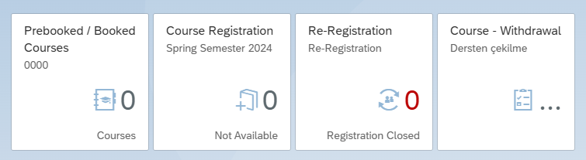
- On the screen that appears, click the “start registration renewal” button. This will complete the registration renewal process.

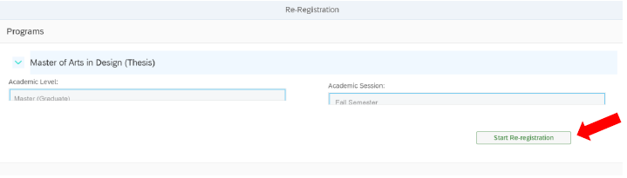

- FEE CALCULATION AND ONLINE PAYMENT TOOLS
- After completing the registration step, you’ll see the student fee calculation & online payment section. Here, the student checks for any existing debt information.
- If you have any payments, you must complete them from the online payment page.
- Students with unpaid debts cannot register for courses.
- If there is any incorrect information regarding your fee details, you must send an email to sgs@khas.edu.tr by stating your student number.
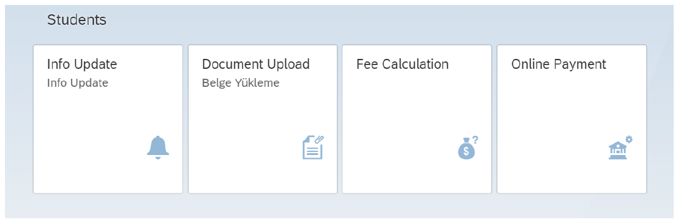

- COURSE REGISTRATION

- Click the Course Registration button as below.
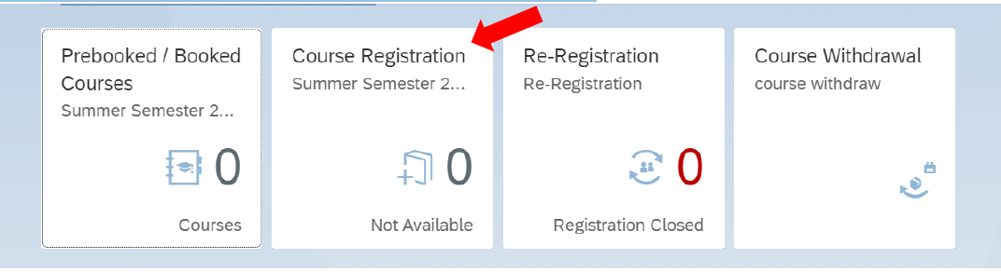

- After that you can see the page below. In the middle of the screen, you can see the obligations you need to complete.
- You can search for the course that you want to register on from the left side of the screen. When you find the lesson, you should click on it for selection.
- You need to add the course to your cart by clicking “add to cart” button. 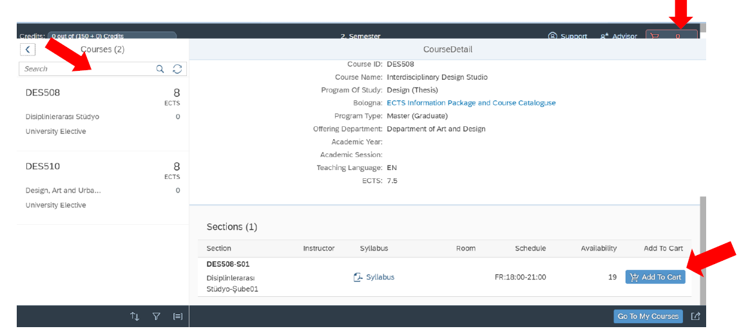

- After adding the courses to the cart, you can see the cart by clicking the cart button on the upper right in the screenshot above.
- On the cart screen, the following screenshot will appear. If there is a course you want to take instead of another course, you need to search for the code of this course from the course section.
- If you want to cancel the course you have added to the cart, you can click the remove button before sending it for approval.
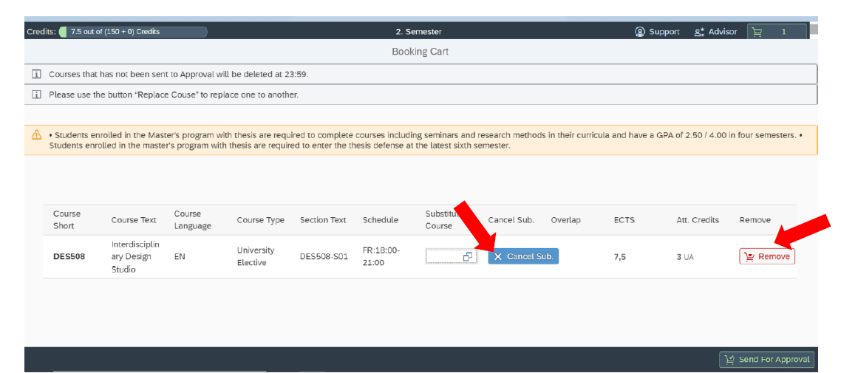

- You can complete your course registration by clicking the “Send for Approval” in the lower right corner of the page.
- While you have courses on advisor approval, you cannot send other courses for advisor approval.
- You may view your registered and prebooked courses from “Prebooked/ Booked Courses”.
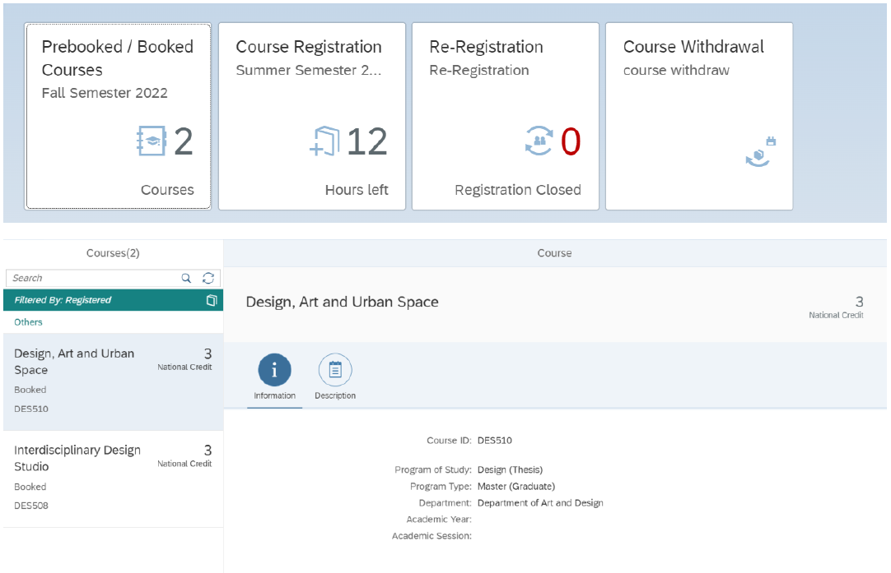

- ADD-DROP
- For adding courses, you may complete the same process as course registration.
- For dropping courses, see the steps below. Click the “Course Registration” button.
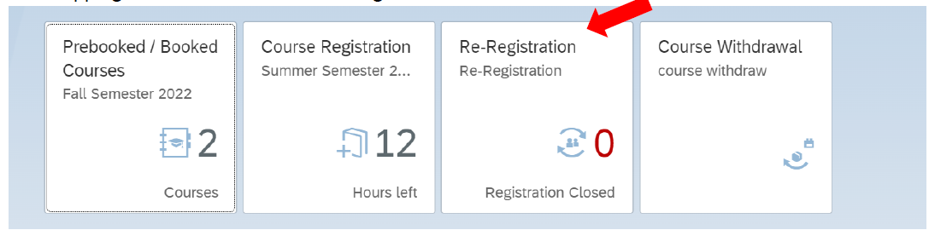
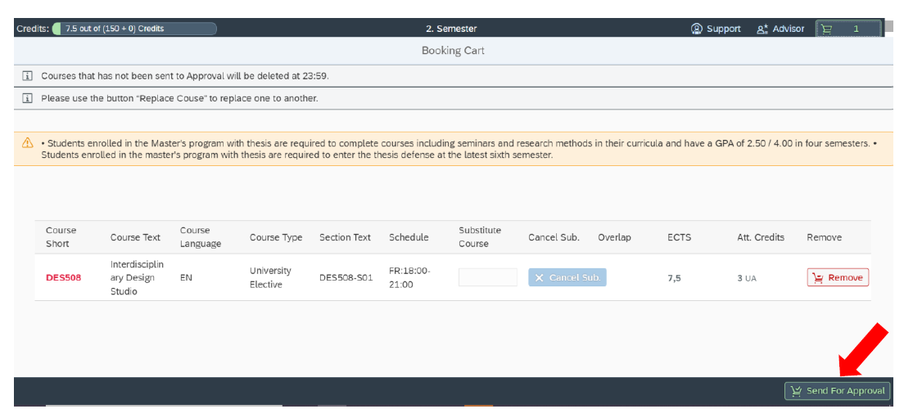
- Select the course and click the drop button for the drop process.
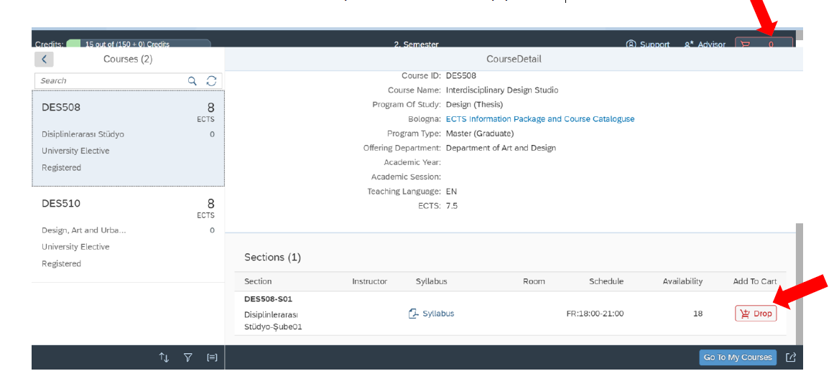
- The course desired to be dropped is added to the cart. When you go to the cart, the screenshot below will appear. When the send to advisor approval button is pressed at the bottom of the screen, the course will be sent to advisor approval to be dropped.

- WITHDRAWAL
- Click the “Course Withdrawal” button.
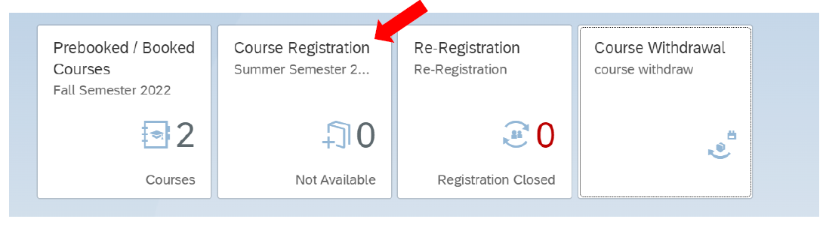
- Select the course you want the withdraw and select the withdraw button.
